**National University of Computer & Emerging Sciences, Karachi  
 School of Computing -Spring 2022  
Mid-2 Examination   
18th April 2022, 08:30 am – 09:30 am** Fast

| **Course Code: CS2006** | **Course Name: Operating System** | |
| --- | --- | --- |
| **Instructor Names: Dr. Ghufran Ahmed, Ms. Anaum Hamid, Ms. Tania Erum, Ms. Mubashra Fayyaz, and Ms. Safia Baloch** | | |
| **Student Roll No:** | | **Section No:** |

Instructions:

* Return the question paper.
* Read each question completely before answering it. There are **4 questions** and **2 pages.**
* All the answers must be solved according to the sequence given in the question paper.

**Time**: 60 minutes. **Max Marks:** **50**

**CPU Scheduling – [Estimated time: 10 mins]  
---------------------------------------------------------------------------------------------------------------------------------**

**Question no. 01 [Marks: 4+3+4 = 11]**

1. Consider a system that has a CPU-bound process, which requires a burst time of 25 seconds. The multilevel Feedback Queue scheduling algorithm is used with TQ=2 sec and in each level, it is incremented by 5 sec. Then how many times the process will be interrupted, and in which queue the process will terminate the execution?

The process needs 25 Seconds for total execution.   
At Queue 1 it is executed for 2 seconds and then interrupted and shifted to queue 2.   
At Queue 2 it is executed for 7 seconds and then interrupted and shifted to queue 3.   
At Queue 3 it is executed for 12 seconds and then interrupted and shifted to queue 4.   
At Queue 4 it is executed for 4 seconds, and it completes.  
Hence the process is interrupted 3 times and completed on queue 4.

1. Explain the processor affinity?



1. Discuss in detail about Load balancing in an operating system.

In SMP, need to keep all CPUs loaded for efficiency.**Load balancing** attempts to keep workload evenly distributed.**Push migration** – periodic task checks load on each processor, and if found pushes task from overloaded CPU to other CPUs**. Pull migration** – idle processors pulls waiting task from busy processor

**Threads and Concurrency – [Estimated time: 15 mins]  
---------------------------------------------------------------------------------------------------------------------------------**

**Question no. 02**  **[Marks:5+5+4=14]**

1. Determine if the following problems exhibit task/data parallelism or both. Give reasons in one or two lines each:
2. Transpose a matrix in parallel.
3. Calculating the salary of all employees of a company.
4. Taking input from IoT cameras in FAST for single abnormal event detection.
5. Taking input from IoT cameras in FAST for scene detection (e.g., books, students, blackboard, teacher. detection modules working in parallel for classroom scene detection.
6. National ID card-making procedure at multiple counters of NADRA.



1. **ABC** is a software industry-made app for machine tool design that can be run 35% parallel on an 8 cores machine. The client needs more speed, **ABC** redesigns the app that can run on 16 cores with 40% parallel code. Discuss the speedup difference.



1. Explain Fork-join operation and illustrate by the diagram?

fork-join is issued by one thread when it wants to stop and wait for the

termination of another thread. On termination of the target thread, the original thread

resumes execution. Grading Scheme: 1 point for this thread waits for the joined-to

thread to finish

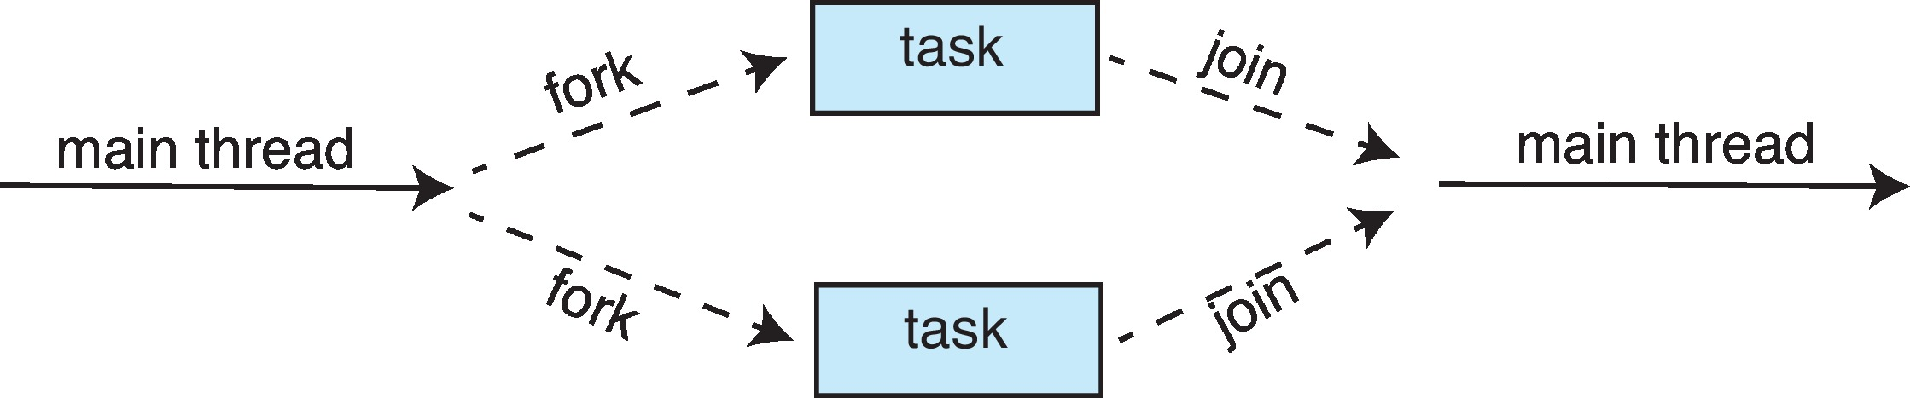

**Process Synchronization and Tools – [Estimated time: 15 mins]  
---------------------------------------------------------------------------------------------------------------------------------**

**Question no. 03 [Marks:6+7=13]**

1. Consider two concurrently running threads: A with operations A1 and A2, and B with operations B1 and B2.

It is required that

- B2 be executed only after A1 has been completed and

- A2 be executed only after B1 has completed

Synchronize threads A and B considering the above requirements.



1. Four agents (AX, BX CX and DX) from terminals of an investment market create processes concurrently. These concurrent processes make changes in the value of Pakistani rupees by modifying the global shared variable: **PKR**. Processes created by agents AX and BX read **PKR** from memory, increment the value by 20K, store it back in memory, and then terminate. Processes created by agents CX, and DX read **PKR** from memory, decrement the value by 40K, store it back in memory, and then terminate. Synchronize and design the strategy to get the maximum possible value of **PKR** after all processes complete their execution?

**Main Memory– [Estimated time: 10 mins]**

**---------------------------------------------------------------------------------------------------------------------------------**

**Question no. 04 [Marks: 3+4+5 = 12]**

1. Suppose P1 is currently in execution required for bringing P2 into main memory via dynamic linking. Main Memory runs out of the capacity due to the degree of multiprogramming. What can be a solution to this problem? Illustrate your answer through a diagram.

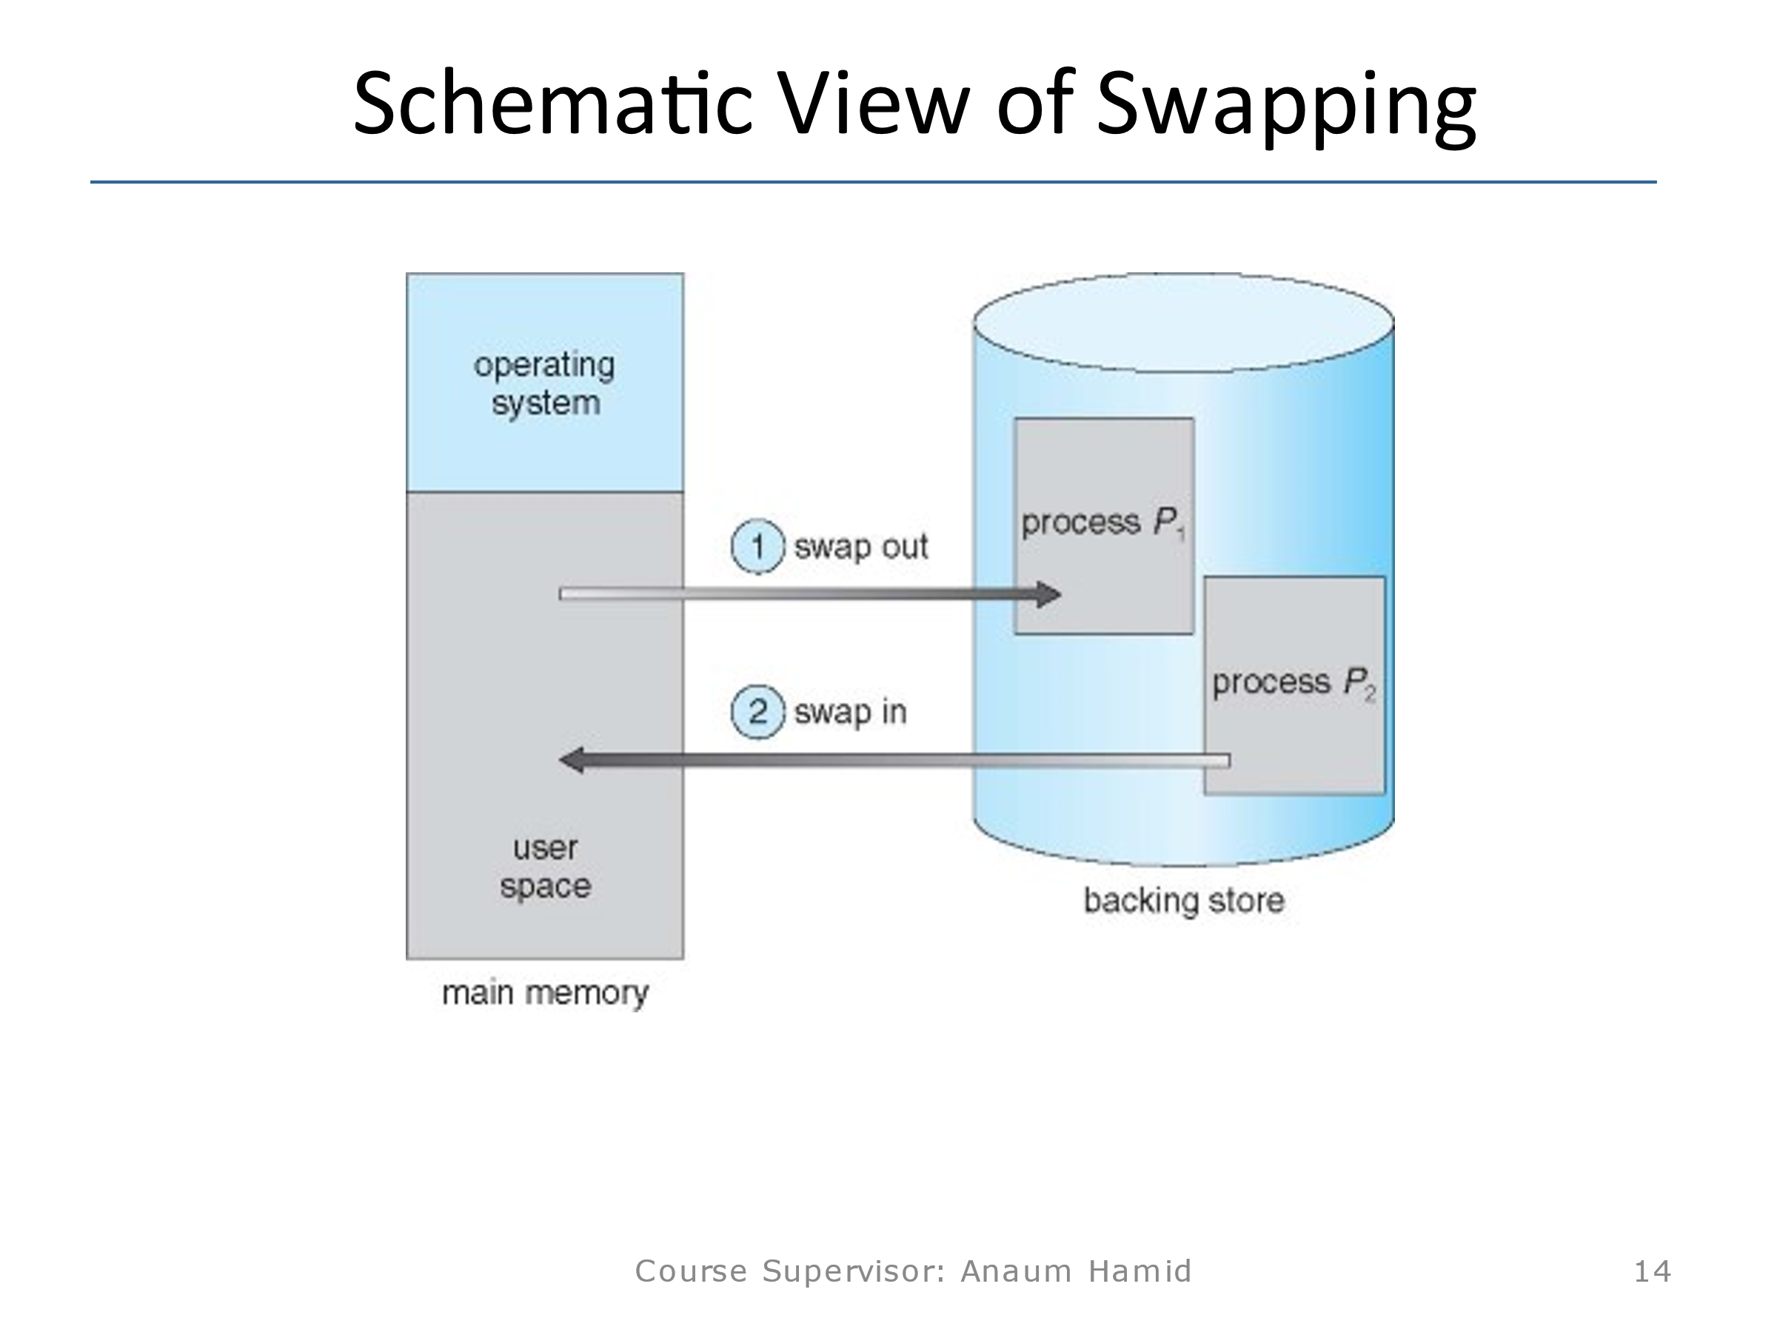

1. Considering the memory protection mechanism, how does an operating system classify an instruction as legal or trap. Describe in detail the security mechanism of a process loaded in memory. Illustrate your answer with a diagram.

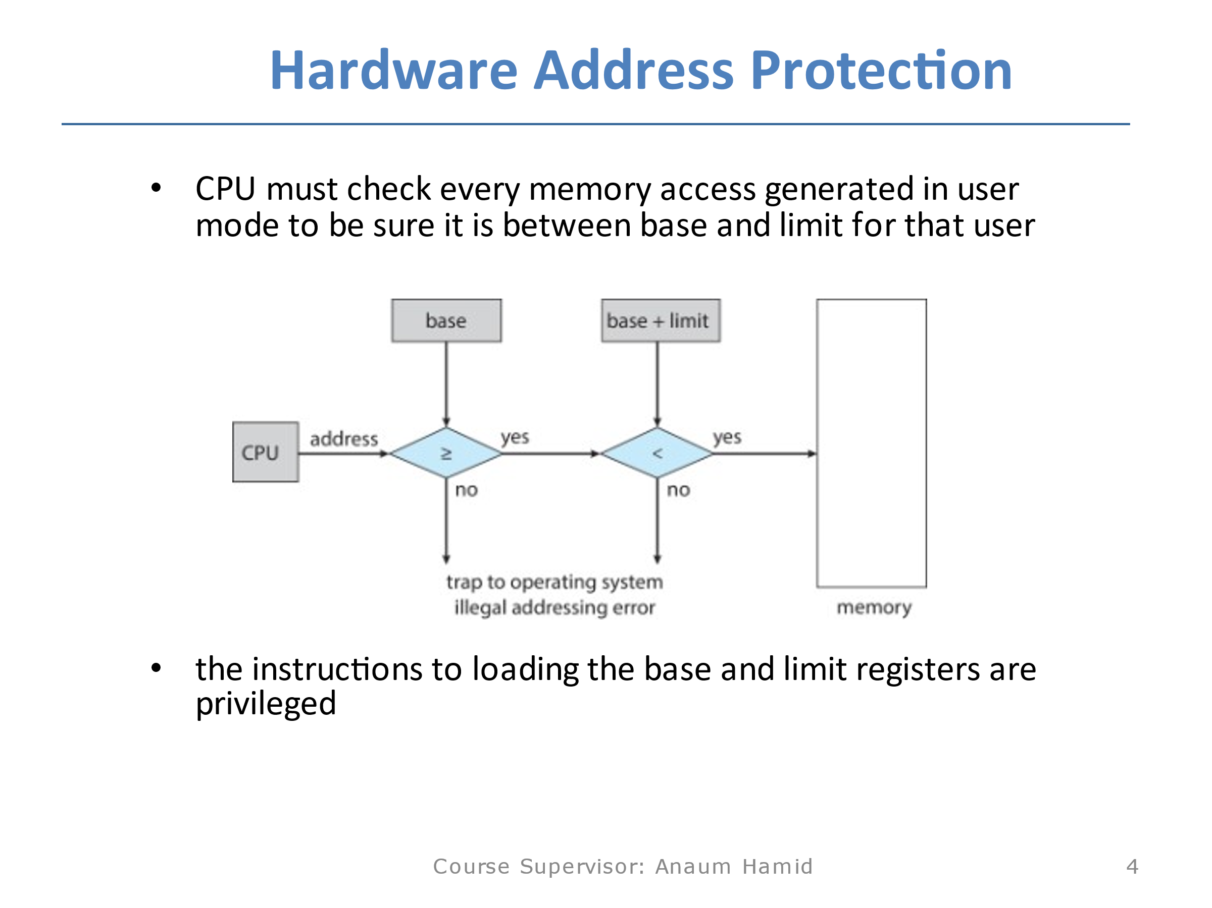

1. Suppose a user process of 3072 KB is rolled-out from main memory to hard disk with a standard transfer rate of 1Mbps. Calculate how long swapping will take if another user’s process of 2048 KB rolls into the main memory.



**\*\*\*\*\*\*\*\*\*\*\*\*Best of Luck\*\*\*\*\*\*\*\*\*\*\*\***